Online Discussion Group System
SR | USER Requirements | GPT Results | VeriGen Results
 | The leader logs into the system. | 1 The system shall provide the leader with the ability to log into the system. | 1. The system shall provide leader with the ability to log in to the system.
 | The system authenticates the leader to start a session. | 2 The system shall be able to authenticate the leader upon login. | 2. The system shall be able to authenticate the leader to start a session.
 | If the system fails to validate the leader then the system shows an error message. | 3 If the system fails to validate the leader during login, then the system shall be able to show an error message to the leader. | 3. If the system fails to validate the leader then the system shall be able to show an error message.
 | The leader chooses to create a new group. | 5 The system shall provide the leader with the ability to create a new discussion group. | 4. The system shall provide leader with the ability to choose to create a new group.
 | The system guides the leader to fill in required information to create the discussion group. | 6 The system shall guide the leader to fill in all required information to create a discussion group. | 5. The system shall be able to guide the leader to fill in required information to create the discussion group.
 | If the system fails to create a new group then the system asks leader to check the information. | 8 If the system fails to create a new discussion group, then the system shall be able to ask the leader to check the information provided. | 6. If the system fails to create a new group then the system shall be able to ask leader to check information.
 | The leader invites other students to join the discussion group by giving invitation message. | 9 The system shall provide the leader with the ability to invite other students to join the discussion group.  10 The system shall provide the leader with the ability to compose an invitation message for students.  11 The system shall be able to deliver the invitation message to the selected students. | 7. The system shall provide leader with the ability to invite other students to join the discussion group by giving invitation message.
 | If system fails to deliver invitation message then the leader is asked to retry the process. | 12 If the system fails to deliver the invitation message, then the system shall be able to ask the leader to retry the process. | 8. If system fails to deliver invitation message then the system shall be able to ask leader to retry process.
 | The system acknowledges that a new discussion group is created. | 13 The system shall be able to acknowledge to the leader that a new discussion group has been created successfully. | 9. The system shall be able to acknowledge that a new discussion group created.
 | There should be at least one existing discussion group. | 14 The system shall ensure that at least one discussion group exists in the system at all times. | 10. The system shall be able to existing discussion group.
 | The student logs in. | 15 The system shall provide the student with the ability to log into the system. | 11. The system shall provide student with the ability to log in.
 | The system authenticates the student. | 16 The system shall be able to authenticate the student upon login. | 12. The system shall be able to authenticate the student.
 | The system starts the session. | 17 The system shall be able to start a session for the student upon successful authentication. | 13. The system shall be able to start the session.
 | If the system fails to validate the student then the system shows an error message. | 18 If the system fails to validate the student during login, then the system shall be able to show an error message to the student. | 14. If the system fails to validate the student then the system shall be able to show an error message.
 | The student chooses to join the existing discussion group. | 19 The system shall provide the student with the ability to join an existing discussion group. | 15. The system shall provide student with the ability to choose to join the existing discussion group.
 | The system guides the student to fill in required information to join the discussion group. | 20 The system shall guide the student to fill in all required information to join a discussion group. | 16. The system shall be able to guide the student to fill in required information to join the discussion group.
 | If the information filled by the student is incomplete then the system shows an error message. | 22 If the information filled by the student to join a discussion group is incomplete, then the system shall be able to show an error message to the student. | 17. If the information filled by the student is incomplete then the system shall be able to show an error message.
 | The system acknowledges that the student has successfully joined the discussion group. | 23 The system shall be able to acknowledge to the student that they have successfully joined the discussion group. | 18. The system shall be able to acknowledge that the successfully joined the discussion group.
 | The student should have joined at least one discussion group. | 24 The system shall ensure that each student has joined at least one discussion group. | 19. The system shall provide student with the ability to join at least one discussion group.
 | The student logs into the system. | Missing | 20. The system shall provide student with the ability to log in to the system.
 | The system authenticates the student to start a session. | Missing | 21. The system shall be able to authenticate the to start a session.
 | If the system fails to validate the student then the system shows an error message. | Missing | 22. If the system fails to validate the student then the system shall be able to show an error message.
 | The student chooses to leave the discussion group. | 25 The system shall provide the student with the ability to leave a discussion group. | 23. The system shall provide student with the ability to choose to leave the discussion group.
 | The student is guided by the system to specify the discussion group he wants to leave. | 27 The system shall be able to process the student’s request to leave the specified discussion group. | 24. The system shall provide student with the ability to guided specify wants leaveThe system shall be able to acknowledge that the successfully left that group.
 | The system acknowledges that the student has successfully left that group. | 28 The system shall be able to acknowledge to the student that they have successfully left the specified discussion group. | Missing
 | If the student is unable to leave the selected discussion group then the system asks the student to retry. | 29 If the student is unable to leave the selected discussion group, then the system shall be able to ask the student to retry the process. | 25. If the student is unable to leave the selected discussion group then the system shall be able to ask student to retry.
 | The student logs into the system. | Missing | 26. The system shall provide student with the ability to log in to the system.
 | The system validate the student to start a session. | 30 The system shall validate the student’s login credentials to start a session. | 27. The system shall be able to validate the student to start a session.
 | If the system fails to validate the student then the system asks student to retry. | 31 If the system fails to validate the student during login, then the system shall be able to ask the student to retry logging in. | 28. If the system fails to validate the student then the system shall be able to ask student to retry.
 | The student chooses to add a presentation. | 32 The system shall provide the student with the ability to add a new presentation. | 29. The system shall provide student with the ability to choose to add a presentation.
 | The system guides the student to fill in required information to add a new presentation. | 33 The system shall guide the student to fill in all required information to add a new presentation. | 30. The system shall be able to guide the student to fill in required information to add a new presentation.
 | The system acknowledges that the presentation is added successfully. | 35 The system shall be able to acknowledge to the student that the presentation has been added successfully. | 31. The system shall be able to acknowledge that the presentation added successfully.
 | If the presentation is not added successfully then the system shows an error message asking to retry. | 36 If the presentation is not added successfully, then the system shall be able to show an error message to the student asking them to retry. | 32. If the presentation is not added successfully then the system shall be able to show an error message asking to retry.
 | The student has to be a member of at least one discussion group. | 37 The system shall ensure that a student is a member of at least one discussion group before allowing them to add a presentation. | 33. The system shall provide student with the ability to have to a member of at least one discussion group.
 | The student logs into the system. | Missing | 34. The system shall provide student with the ability to log in to the system.
 | The system authenticates the student to start a session. | Missing | 35. The system shall be able to authenticate the student to start a session.
 | If the system fails to validate the student then the system asks student to enter login id with password again. | Missing | 36. If the system fails to validate the student then the system shall be able to ask student to enter login i d with password again.
 | The student chooses to edit a presentation. | Missing | 37. The system shall provide student with the ability to choose to edit a presentation.
 | The student edits the presentation. | 38.The system shall provide the student with the ability to edit an existing presentation. | 38. The system shall provide student with the ability to edit the presentation.
 | The system asks student to save the changes made by him. | 40 The system shall provide the student with the ability to save changes made to the presentation. | 39. The system shall be able to ask student to save the changes made by him.
 | If the student selects not to save the changes then no changes in the presentation is saved. | 42 If the student selects not to save the changes, then the system shall ensure that no changes are saved to the presentation. | 40. If the student selects not to save the changes then the system shall be able to save no changes in presentation saved.
 | The system acknowledges that the presentation has been saved. | 43 The system shall be able to acknowledge to the student that the presentation has been saved. | 41. The system shall be able to acknowledge that the presentation saved.
 | The leader must be logged in. | 44 The system shall ensure that the leader is logged in before allowing leader-specific actions. | 42. The system shall provide leader with the ability to logged in.
 | The leader logs into the system. | Missing | 43. The system shall provide leader with the ability to log in to the system.
 | The system authenticates the leader to start a session. | Missing | 44. The system shall be able to authenticate the leader to start a session.
 | If the user is not registered as a leader then an error message is shown by the system. | 45 If a user is not registered as a leader and attempts to log in as a leader, then the system shall be able to show an error message. | 45. If the user is not registered as a leader then the system shall be able to show an error message.
 | Only leader is allowed to delete a presentation. | 46 The system shall restrict the ability to delete a presentation to leaders only. | 46. The system shall provide leader with the ability to allowed deleteThe system shall be able to guide the leader to delete a presentation.
 | The system guides the leader to delete a presentation. | 47 The system shall guide the leader through the process of deleting a presentation. | Missing
 | The system acknowledges that the presentation has been deleted. | 49 The system shall be able to acknowledge to the leader that the presentation has been deleted. | 47. The system shall be able to acknowledge that the presentation deleted.
 | The student has to be a registered student. | 50 The system shall ensure that a student is a registered student before allowing student-specific actions. | 48. The system shall provide student with the ability to have to a registered student.
 | The student logs into the system. | Missing | 49. The system shall provide student with the ability to log in to the system.
 | The system authenticates the student to start a session. | Missing | 50. The system shall be able to authenticate the to start a session.
 | If the system fails to validate the student then the system asks student to retry. | 51 If the system fails to validate the student during login, then the system shall be able to ask the student to retry logging in. | 51. If the system fails to validate the student then the system shall be able to ask student to retry.
 | The student chooses to add a comment. | 52 The system shall provide the student with the ability to add a new comment. | 52. The system shall provide student with the ability to choose to add a comment.
 | The system guides the student to fill in required information to add a new comment. | 53 The system shall guide the student to fill in all required information to add a new comment. | 53. The system shall be able to guide the student to fill in required information to add a new comment.
 | The system acknowledges that the comment is added successfully. | 55 The system shall be able to acknowledge to the student that the comment has been added successfully. | 54. The system shall be able to acknowledge that the comment added successfully.
 | If the comment is not added successfully then the system shows an error message asking to retry. | 56 If the comment is not added successfully, then the system shall be able to show an error message to the student asking them to retry. | 55. If the comment is not added successfully then the system shall be able to show an error message asking to retry.
 | The student has to be a member of at least one discussion group. | 57 The system shall ensure that a student is a member of at least one discussion group before allowing them to add a comment. | 56. The system shall provide student with the ability to have to a member of at least one discussion group.
 | The student logs into the system. | Missing | 57. The system shall provide student with the ability to log in to the system.
 | The system authenticates the student to start a session. | Missing | 58. The system shall be able to authenticate the student to start a session.
 | If the system fails to validate the student then the system asks student to enter login id with password again. | 58 If the system fails to validate the student during login, then the system shall be able to ask the student to enter their login ID and password again. | 59. If the system fails to validate the student then the system shall be able to ask student to enter login i d with password again.
 | The student chooses to edit a comment made by him. | 59 The system shall provide the student with the ability to edit a comment made by themselves. | 60. The system shall provide student with the ability to choose to edit a comment made by him.
 | If the student tries to edit a comment made by someone else then the system shows an error message. | 60 If the student attempts to edit a comment made by another user, then the system shall be able to show an error message. | 61. If the student tries to edit a comment made by someone else then the system shall be able to show an error message.
 | The student edits the comment. | 61 The system shall present the existing comment details to the student for editing. | 62. The system shall provide student with the ability to edit the comment.
 | The system asks student to save the changes made by him. | 62 The system shall provide the student with the ability to save changes made to their comment. | 63. The system shall be able to ask student to save the changes made by him.
 | If the student selects not to save the changes then no changes in the comment is saved. | 64 If the student selects not to save the changes, then the system shall ensure that no changes are saved to the comment. | 64. If the student selects not to save the changes then the system shall be able to save no changes in comment saved.
 | The system acknowledges that the new comment has been saved. | 65 The system shall be able to acknowledge to the student that the comment has been saved. | 65. The system shall be able to acknowledge that the new comment saved.
 | The leader must be logged in. | 66 The system shall ensure that the leader is logged in before allowing leader-specific actions related to comments. | 66. The system shall provide leader with the ability to logged in.
 | The leader logs into the system. | Missing | 67. The system shall provide leader with the ability to log in to the system.
 | The system authenticates the leader to start a session. | Missing | 68. The system shall be able to authenticate the leader to start a session.
 | If the user is not registered as a leader then an error message is shown by the system. | 67 If a user is not registered as a leader and attempts to log in as a leader, then the system shall be able to show an error message. | 69. If the user is not registered as a leader then the system shall be able to show an error message.
 | Only leader is allowed to delete a comment. | 68 The system shall restrict the ability to delete a comment to leaders only. | 70. The system shall provide leader with the ability to allowed deleteThe system shall be able to guide the leader to delete a comment.
 | The system guides the leader to delete a comment. | 69 The system shall guide the leader through the process of deleting a comment. | Missing
 | The system acknowledges that the comment has been deleted. | 71 The system shall be able to acknowledge to the leader that the comment has been deleted. | 71. The system shall be able to acknowledge that the comment deleted.
 |  | 4 The system shall be able to start a session for the leader upon successful authentication.
 |  | 7 The system shall be able to validate the information provided by the leader for creating a discussion group.
 |  | 21 The system shall be able to validate the information provided by the student for joining a discussion group.
 |  | 26 The system shall guide the student to specify the discussion group they wish to leave.
 |  | 34 The system shall be able to validate the information provided by the student for adding a new presentation.
 |  | 39 The system shall be able to present the existing presentation details to the student for editing.
 |  | 41 The system shall prompt the student to save the changes made to the presentation.
 |  | 48 The system shall be able to delete the specified presentation upon leader’s request.
 |  | 54 The system shall be able to validate the information provided by the student for adding a new comment.
 |  | 63 The system shall prompt the student to save the changes made to the comment.
 |  | 70 The system shall be able to delete the specified comment upon leader’s request.
 |  | 72 The system shall ensure that all required fields for group creation, joining, presentation, and comment are validated for completeness.
 |  | 73 The system shall provide appropriate feedback messages for all successful and unsuccessful operations.
 |  | 74 The system shall log all authentication attempts for both leaders and students.
 |  | 75 The system shall terminate the session if authentication fails after a configurable number of attempts.
 |  | 76 The system shall maintain an audit trail of all group, presentation, and comment creation, modification, and deletion actions.
 |  | 77 The system shall prevent duplicate group names during group creation.
 |  | 78 The system shall prevent duplicate presentation titles within the same discussion group.
 |  | 79 The system shall prevent duplicate comments by the same student on the same presentation within a short time frame.
 |  | 80 The system shall provide the ability to resend invitation messages if delivery fails.
 |  | 81 The system shall ensure that only group members can add presentations or comments to that group.
 |  | 82 The system shall restrict editing and deletion of presentations and comments to their respective owners or the leader, as appropriate.
 |  | 83 The system shall provide clear error messages specifying the reason for failure in all operations.
 |  | 84 The system shall allow the leader to view the list of invited students and their invitation status.
 |  | 85 The system shall allow students to view the groups they have joined.
 |  | 86 The system shall prevent students from joining the same group more than once.
 |  | 87 The system shall prevent students from leaving a group if they are not a member of that group.
 |  | 88 The system shall ensure that at least one leader exists in the system at all times.
 |  | 89 The system shall ensure that a student cannot add, edit, or delete presentations or comments unless authenticated and authorized.
 |  | 90 The system shall provide session timeout and automatic logout after a period of inactivity for both leaders and students.

Class Diagram (GPT)
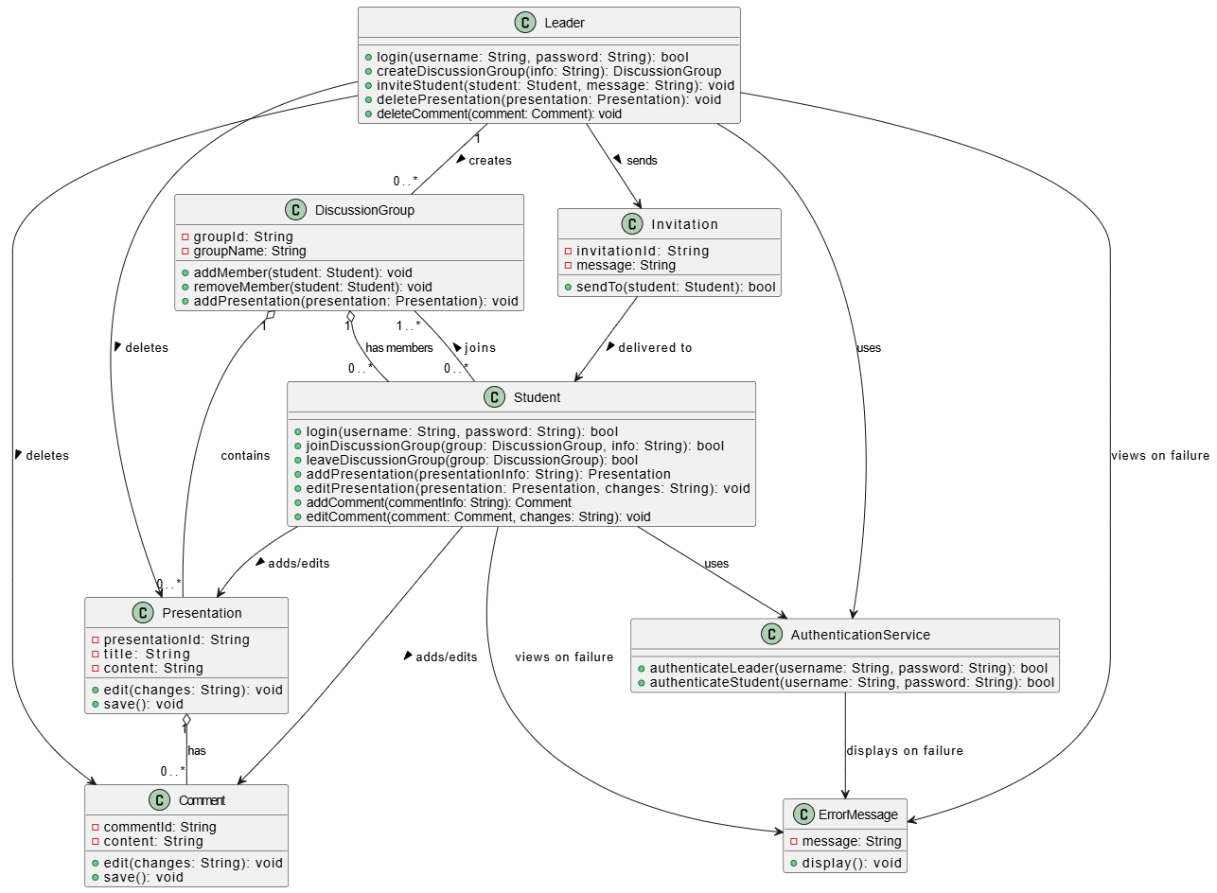

Class Diagram (VeriGen)

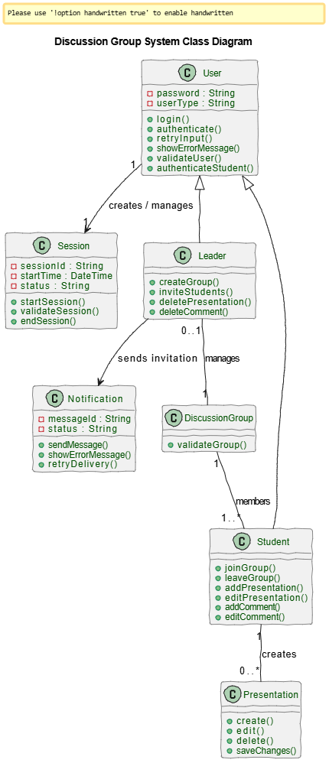

Sequence Diagram (VeriGen)

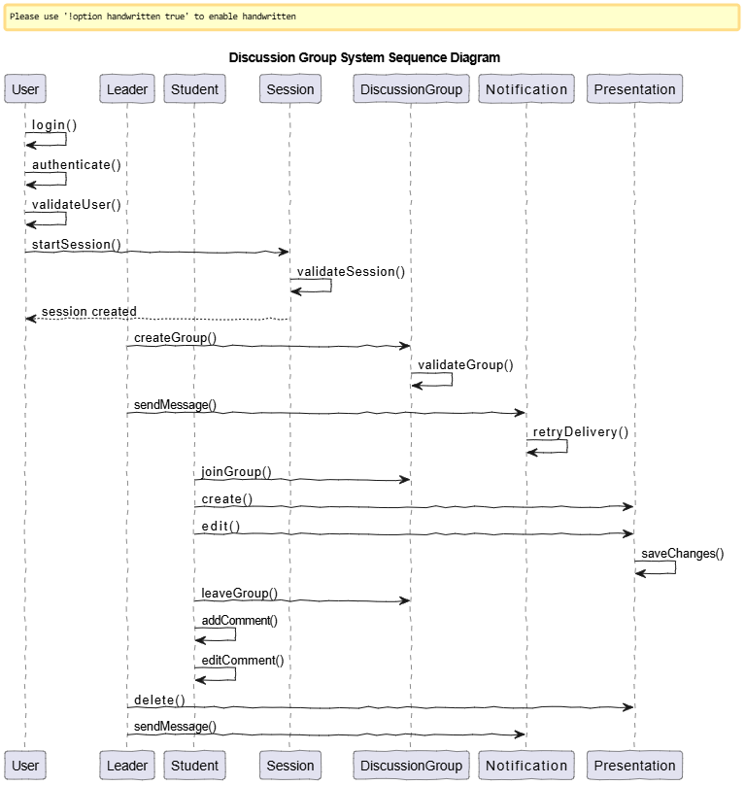

Sequence Diagram (GPT)

